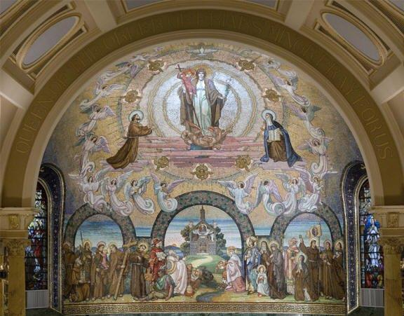

Our Lady of the Rosary
Secular Franciscan Fraternity
Williamsburg, Virginia

February 2017

(The Great Mosaic which covers the entire surface of the sanctuary in the Church of Saint Francis of
Assisi in New York City depicts the theme of Mary, Queen of the Order of Friars Minor, receiving the love and honor bestowed on her by Franciscans throughout the centuries.)

This is a test to see if my group contact list is working correctly and to introduce everyone to the proposed new format of our newsletter. Given the name of our fraternity, I thought it would be appropriate to honor Mary in our template. You can get more about this mosaic on the internet.

Council members: please let me know what you think and get your inclusions for the February newsletter to me by February 6th.

Peace, Chuck

