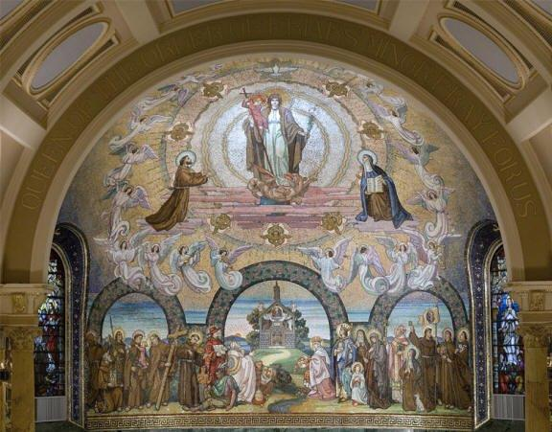

Our Lady of the Rosary
Secular Franciscan Fraternity
Williamsburg, Virginia

May 2017
www.olrsfo.weebly.com

Minister’s Reflections
Terry Carlino, OFS

As listed in our Rule (Art 8), Secular Franciscans are required to join the Church in the keeping of the Divine Office, praying at least three times a day, one of the various forms of Liturgical Prayer. The most universal form of this daily prayer is the single volume Christian Prayer or the four-volume version of the Liturgy of the Hours, supplemented by the Proper Offices of the Franciscan Saints and Blesseds. Saying The Little Office of The Blessed Virgin Mary also fulfills the requirement for daily prayer. A number of other options are also listed on page 103 of the Ritual book.
Recently, in the last couple of years, a new prayer book for morning and evening prayer has become available. Organized by the Third Order Regular congregations with the assistance of many Secular Franciscans, the two-volume Franciscan Morning and Evening Prayer Book has been released. Like Christian Prayer, it contains a four-week psalter, a seasonal prayer section for Sundays, a Proper of Saints which includes the Franciscans Saints and Blesseds, and Commons for various purposes. This includes the normal commons of Apostles, the Blessed Virgin Mary, prayer for the Dead, but also Commons for members of the First, Second, and Third Orders, and for Married Couples.
One thing that makes these books so special is their use of Franciscan sources. Each morning and evening, as well as a Gospel reading, there is also a reading based on a Franciscan source. This book is published by Tau Publishing and is available through Amazon.
Whichever source you choose to use for your daily prayers, try to be diligent in their performance. Sometimes when you have the least time, the importance of stepping out of yourself to join the Church in prayer is the thing you need to do most.
Pax et bonum
Vice Minister’s Corner
Bea Sanford, OFS

Congratulations to our newly professed Secular Franciscans, Peg Crews, Maria Fuentes-Herman, Donna Kendall, Eileen Murray, and Karen Rutherford-Coulson, who participated in the Rite of Profession on Saturday, April 22. Many of our sisters and brothers witnessed the ritual that was part of the Eucharist concelebrated at Saint Bede Catholic Church by Monsignor Timothy Keeney, Father John David Ramsey, and Father James Kauffmann. Family members and friends traveled from near and far to be a part of this momentous day in the life of the professed. Adjourning to Kaplan Parish Hall, our fraternity members, family and friends participated in the Couples Date Night that takes place one Saturday a month and enjoyed a scrumptious dinner followed by a delicious chocolate Tau cake provided by Chuck and Marie Stephan.
So now what? According to Brother Felice Cangelosi, OFM, CAP, "The Brothers and Sisters called to the Franciscan life in the Secular Fraternity make their Profession during a specific celebration according to the Ritual proper to the SFO. This aspect is by no means insignificant, because the celebration constitutes the foundational moment of the identity of the professed, and is simultaneously the condition for a dialogue to take place in response to God’s action. In fact, the consequences of the commitment a human being expresses by means of a promise derive from a prior commitment, that of God to man. Professing a form of evangelical life, living their consecration to God in the world and for the world, and “transmitting into world affairs the genuine spirit of the gospel” (Ritual, III. 46), Secular Franciscans bear witness that the sanctification of the world necessarily occurs through the sanctification of people, because this world cannot be transformed without the spirit of the beatitudes (cfr. LG 31)”.
May we all use this Rite of Profession to reflect on how we have been called by the Holy Spirit to live the Gospel and draw others to this spirituality that is expressed through the pillars including compassion, care for creations, conflict resolution, and community. Pace e bene,

A JOYOUS AND GLORIOUS DAY

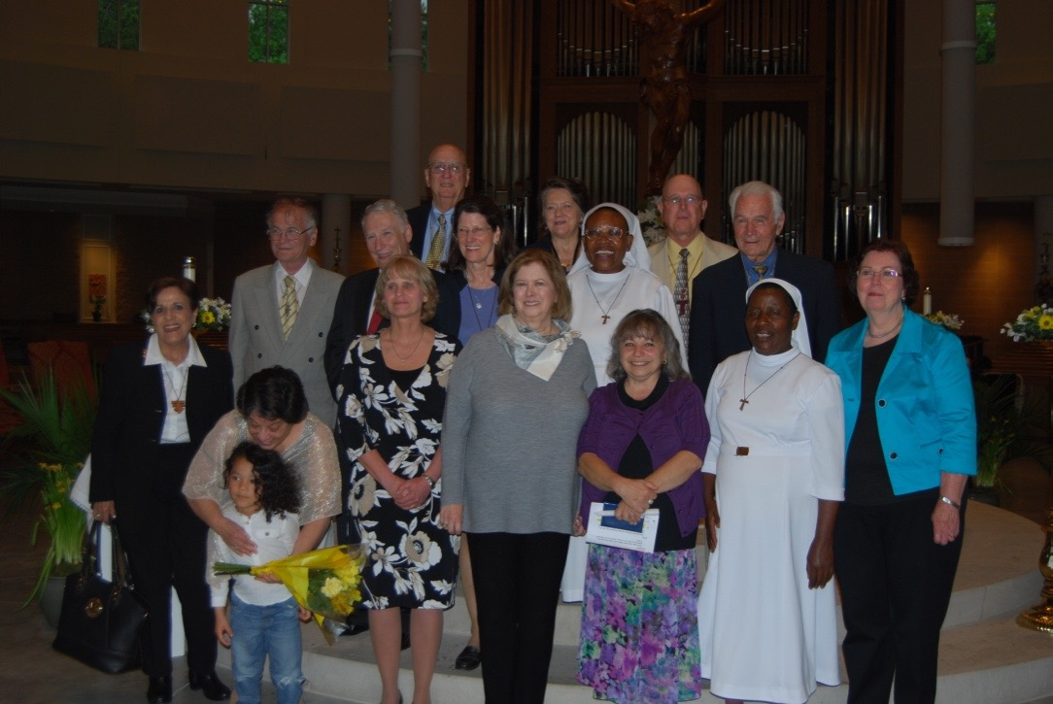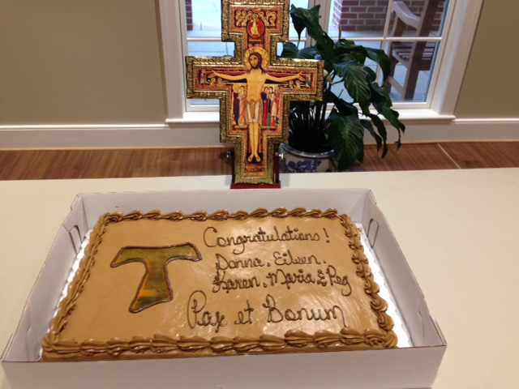

The Holy Father’s prayer intention for May

“That Christians in Africa, in imitation of the Merciful Jesus, may give
prophetic witness to reconciliation, justice and peace”

Did you know?

That Joan of Arc was a Third Order Franciscan
And that her feast is celebrated on May 30.

Happy Birthday!

Cindy Holland 5/21
Maria Fuentes-Sherman 5/25
Margaret Murphy 5/28

Our Annual Regional Secular Franciscan Retreat took place
At Priestfield, WV from April 28 to April 30.
Our Retreat Director was Father Bernard Tickerhoof, TOR, who led us in a spiritually uplifting weekend retreat on “Breaking Free: The Transformation of Daily Life.”
Our fraternity was well represented by six of our members who were
fortunate and blessed to have been able to attend.

Father James Kauffmann, Rector of the National Shrine of Our Lady of Washington, gave a presentation as part of the Lenten Retreat held in Kaplan Parish Hall on Saturday, April 8. His talk centered on the Readings for Holy Week,

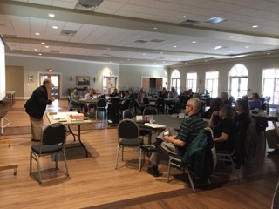
connecting them to the Holy Land sites. More than 25 members and guests were riveted by this engaging program and many came together for lunch at the Bakers Crust after the presentation.

OUR NEXT MEETING
May 21 at St. Bedes -- Father Walsh Room
1:00 Members gather
1:30 Opening Prayer

LOL (laugh out loud)
